VTU Question – June 2025 Biology for Engineers – BBOK407
 |  | Module 1 | M | L | C
Q.1 | a | What are Nucleic acids? Mention its properties and functions. | 10 | L3 | CO1
 | b | Write a short note on all the four types of stem cells. | 10 | L2 | CO1
Or
Q.2 | a | Explain the similarities and differences between plant and animal cell. | 10 | L3 | CO1
 | b | Explain the properties and functions of hormones. | 10 | L2 | CO1
Module 2
Q.3 | a | Explain the application of carbohydrates as cellulose-based water filters, mention its advantages. | 10 | L3 | CO2
 | b | Write a short note on PLA as bioplastic. | 10 | L2 | CO2
Or
Q.4 | a | Explain the DNA vaccine for rabies. | 10 | L3 | CO2
 | b | Discuss the following  - Meat analog of proteins  - Lipids as cleaning agents | 10 | L2 | CO2
Module 3
Q.5 | a | Explain eye as a camera system. | 10 | L3 | CO3
 | b | Describe the architecture of lungs and gas exchange mechanism. | 10 | L2 | CO3
Or
Q.6 | a | Explain the kidney as filtration system. | 10 | L3 | CO3
 | b | Write a short note on Chronic Obstructive Pulmonary Disease (COPD). | 10 | L2 | CO3
Module 4
Q.7 | a | Write a short note on:  (i) Lotus Leaf effect (ii) Shark skin | 10 | L2 | CO4
 | b | Illustrate the HBO’s and PFC’s as human blood substitutes. | 10 | L2 | CO4
Or
Q.8 | a | Write a short note on:  (i) Photovoltaic cells (ii) Bionic leaf | 10 | L2 | CO4
 | b | Describe the engineering applications of GPS and Velcro technology. | 10 | L2 | CO4
Module 5
Q.9 | a | Analyze the bio-engineering solutions for muscular dystrophy and osteoporosis. | 10 | L2 | CO5
 | b | Write a short note on self-healing bio-concrete. | 10 | L2 | CO5
Or
Q.10 | a | Examine the bioimaging and artificial intelligence for disease diagnosis. | 10 | L2 | CO5
 | b | Explain the process of biomining via microbial surface adsorption. | 10 | L2 | CO5

Module – 1

1a. What are Nucleic acids? Mention its properties and functions.
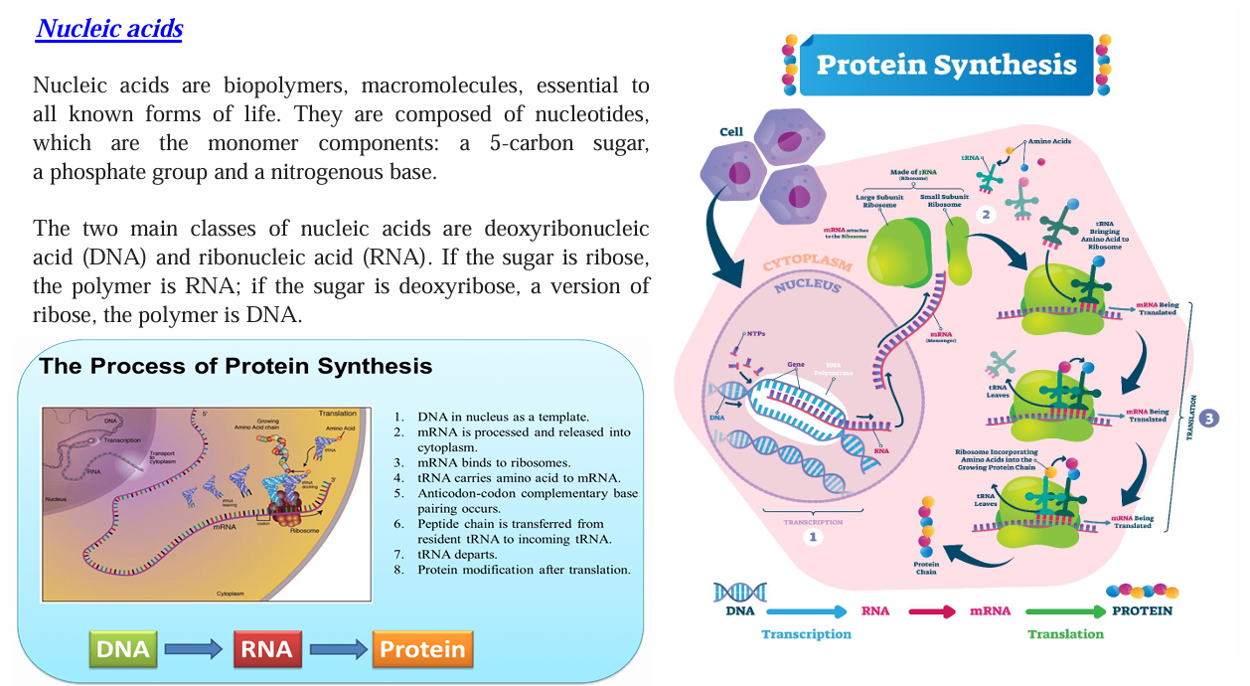
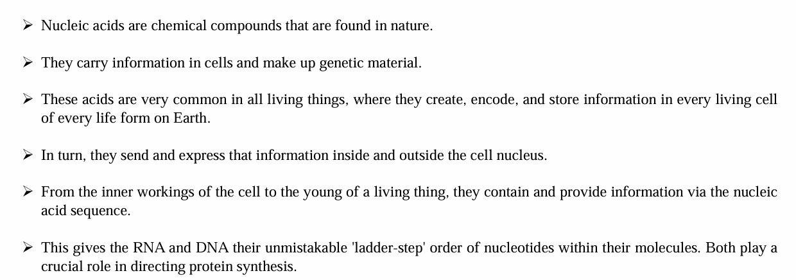

1b. Write a short note on all the four types of stem cells.
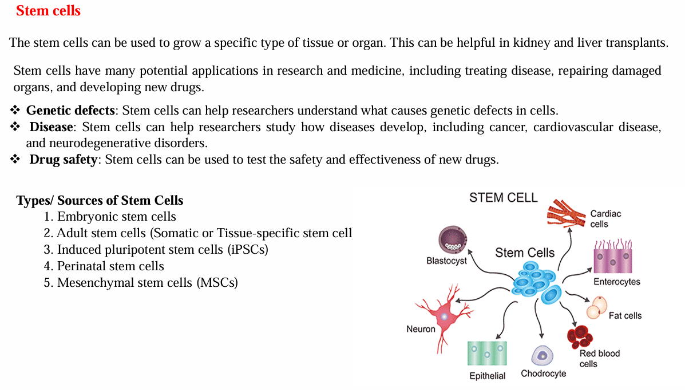
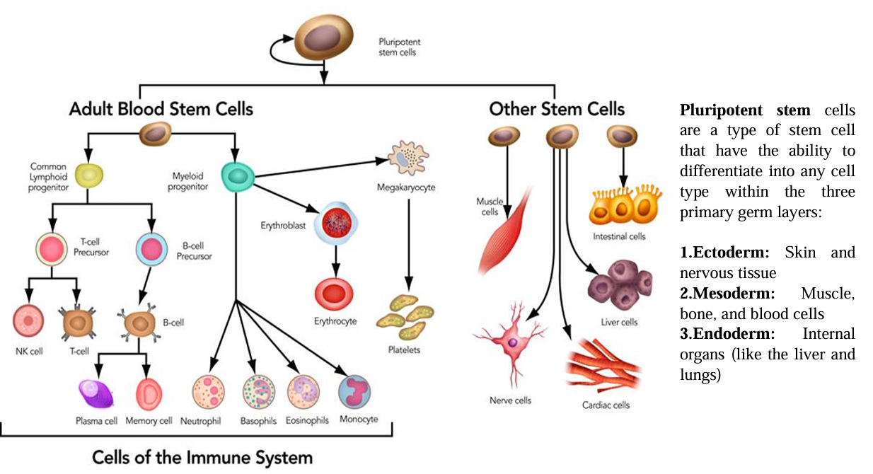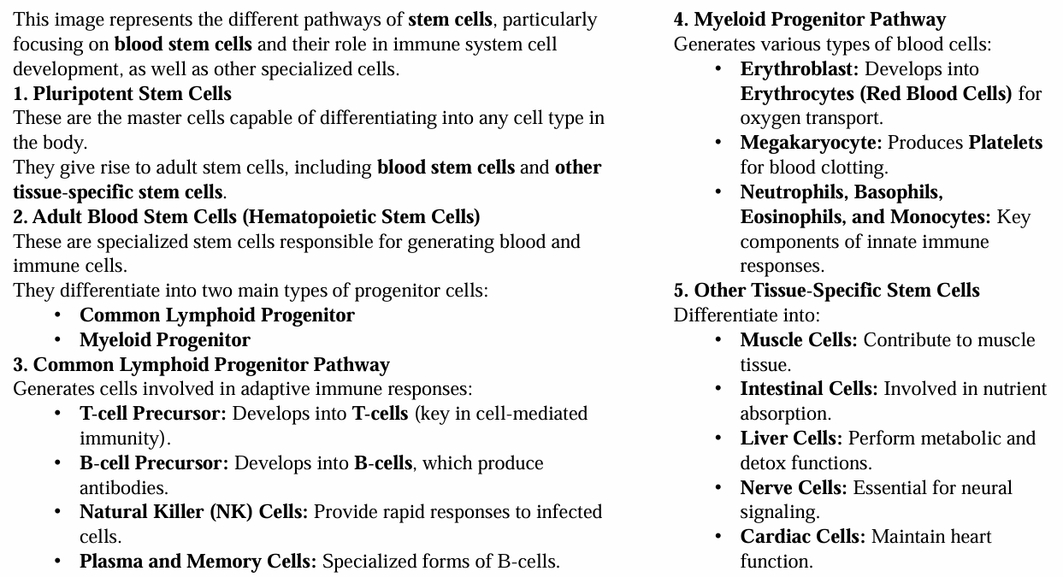

2a. Explain the similarities and differences between plant and animal cell.
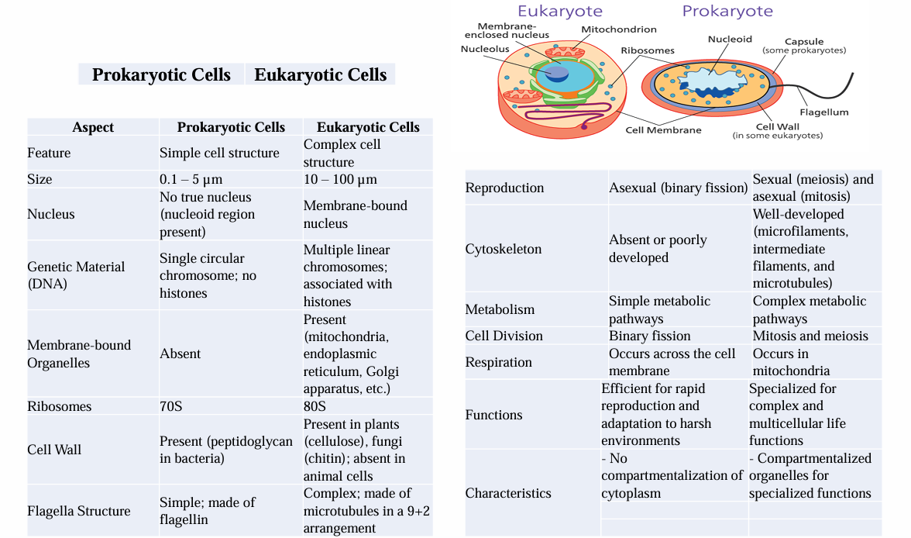
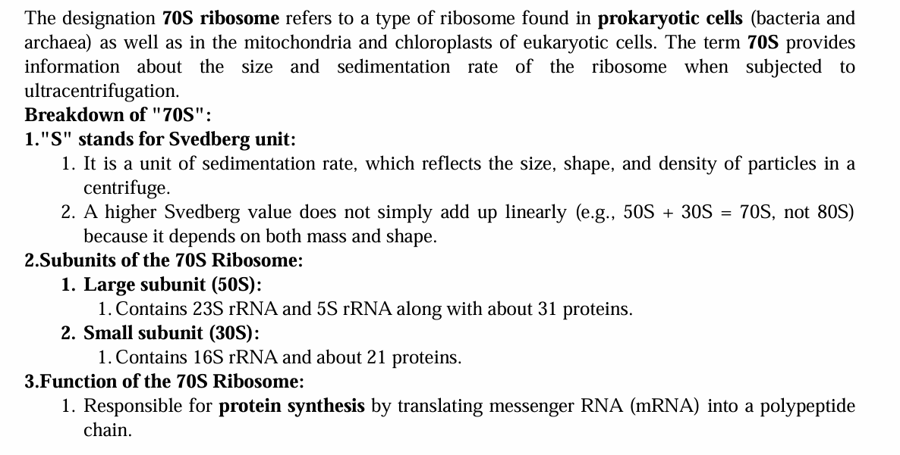
2b. Explain the properties and functions of hormones.
Properties and Functions of Hormones
Properties of Hormones:
- Chemical Messengers: Hormones are secreted by endocrine glands and act as messengers to regulate physiological activities.
- Produced in Small Quantities: They are effective in very low concentrations.
- Specificity: Each hormone acts on specific target organs or cells that have appropriate receptors.
- Transported via Bloodstream: Hormones travel through the blood to reach target sites.
- Regulated Secretion: Their secretion is tightly regulated by feedback mechanisms.
- Short or Long-Term Effects: Some act quickly (e.g., adrenaline), while others take longer (e.g., growth hormone).
- Do Not Supply Energy: Hormones are not used as a source of energy but regulate energy metabolism.
Functions of Hormones:
- Regulation of Metabolism: Hormones like insulin and thyroid hormones regulate metabolic rate and glucose levels.
- Growth and Development: Growth hormone and sex hormones control physical development and puberty.
- Homeostasis Maintenance: Hormones like ADH and aldosterone help maintain water and electrolyte balance.
- Reproductive Functions: Estrogen, progesterone, and testosterone regulate reproductive processes.
- Response to Stress: Cortisol and adrenaline help the body cope with stress.
- Mood and Behaviour: Hormones such as serotonin and dopamine influence mood and behaviour.

Module – 2

3a. Explain the application of carbohydrates as cellulose-based water filters, mention its advantages.

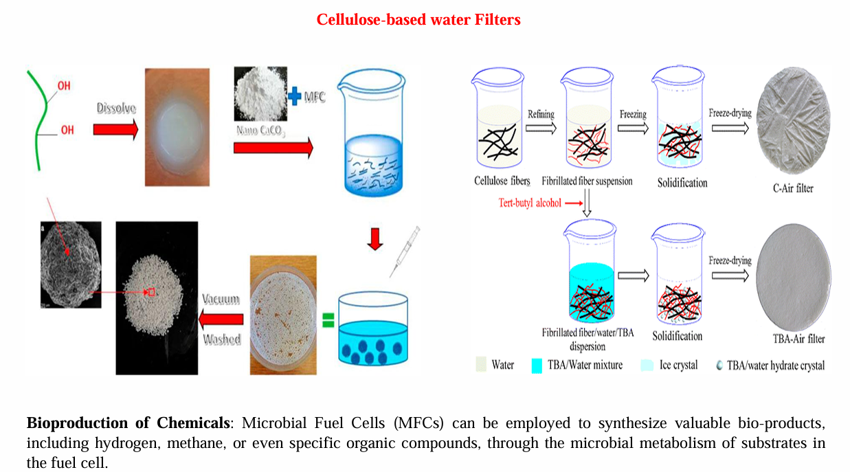
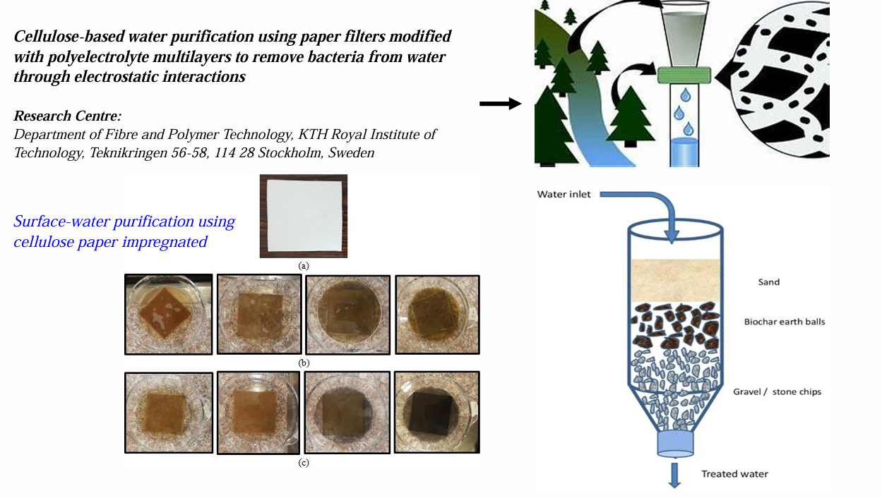

3b. Write a short note on Meat analogue and Plant protein as food.
With increasing awareness of health, sustainability, and ethical concerns associated with conventional animal farming, plant-based diets have gained popularity. Among these innovations, meat analogues and plant proteins play a pivotal role in providing nutritional substitutes for animal-based foods without compromising on taste or health benefits.

1. Meat Analogue:
Definition:
Meat analogues, also known as mock meat, plant-based meat, or meat substitutes, are food products designed to simulate the flavor, texture, appearance, and nutritional value of conventional meat using plant-derived ingredients.
Common Ingredients:
- Soy protein isolate
- Wheat gluten (seitan)
- Pea protein
- Mushroom extracts
- Legumes and pulses
Nutritional Aspects:
- High in protein and dietary fiber
- Often low in saturated fats and cholesterol-free
- Can be fortified with vitamins and minerals like B12 and iron
Advantages:
- Promotes sustainable food production
- Reduces greenhouse gas emissions
- Suitable for vegetarians and vegans
- Helps prevent animal cruelty
Limitations:
- Some products may be high in sodium or over-processed
- Allergen risks (e.g., soy, gluten)

2. Plant Protein as Food:
Definition:
Plant protein refers to protein that is sourced from plants, including legumes, whole grains, nuts, seeds, and vegetables.
Sources of Plant Protein:
- Soybeans, lentils, chickpeas
- Quinoa, brown rice
- Almonds, chia seeds, pumpkin seeds
Nutritional Benefits:
- Contains essential amino acids (especially when diversified)
- Rich in fiber, antioxidants, and micronutrients
- Supports heart health and reduces risk of chronic diseases
Applications:
- Used in protein supplements, meat alternatives, dairy substitutes (e.g., soy milk, almond milk)
- Incorporated in traditional diets and modern food tech

4a. Explain the DNA vaccine for rabies.
Rabies is a fatal viral disease caused by the Rabies virus, which affects the central nervous system. It is commonly transmitted to humans through the bite or scratch of infected animals (typically dogs). Once symptoms appear, rabies is almost always fatal, making early vaccination crucial.

What is a DNA Vaccine?
A DNA vaccine is a type of vaccine that uses genetically engineered DNA to induce an immune response. It involves injecting a small, circular piece of DNA (called a plasmid) containing genes that code for antigens (proteins) of the virus. The host cells take up this DNA, produce the viral proteins, and trigger an immune response.

Mechanism of DNA Vaccine for Rabies:
- Plasmid Design:
The DNA vaccine for rabies contains a gene encoding the rabies virus glycoprotein (G protein), which is essential for inducing protective immunity.
- Delivery into Host Cells:
The plasmid is injected into muscle or skin tissue using a needle or gene gun.
- Antigen Expression:
Host cells take up the DNA and produce the rabies glycoprotein.
- Immune Response:
The expressed antigen is recognized by the immune system, activating both:
  - Humoral immunity (antibody production)
  - Cell-mediated immunity (T-cell activation)
This helps the immune system recognize and neutralize the actual rabies virus upon future exposure.

Advantages of DNA Vaccine for Rabies:
- Safe – Non-infectious and does not use live virus.
- Stable – DNA is more stable and doesn’t require cold storage.
- Cost-effective – Easy to produce and scale.
- Long-lasting immunity – Stimulates both B and T cell responses.
- Rapid Development – Especially useful in pandemics or outbreaks.

Current Status and Use:
- Several DNA-based rabies vaccines have shown promising results in animal models (dogs, mice, monkeys).
- Human clinical trials are underway in different parts of the world.
- They may be used in the future as pre-exposure prophylaxis or even post-exposure treatment.

DNA vaccines represent a modern and promising approach to combat rabies, particularly in areas where cold-chain limitations and rapid response are challenges. Though still under clinical development, DNA vaccines for rabies could revolutionize how we prevent and control this deadly disease.

4b. Write a short note on PLA as bioplastic.
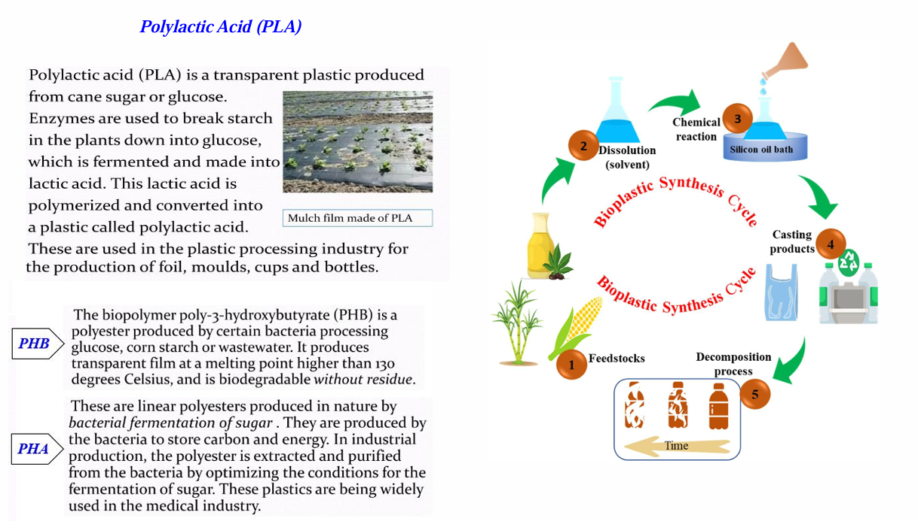

Module – 3

5a. Explain eye as a camera system.

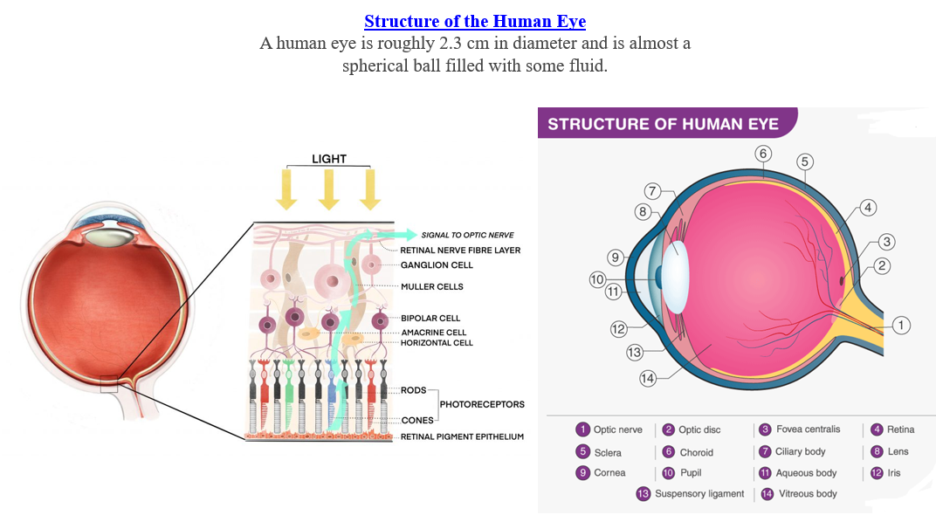
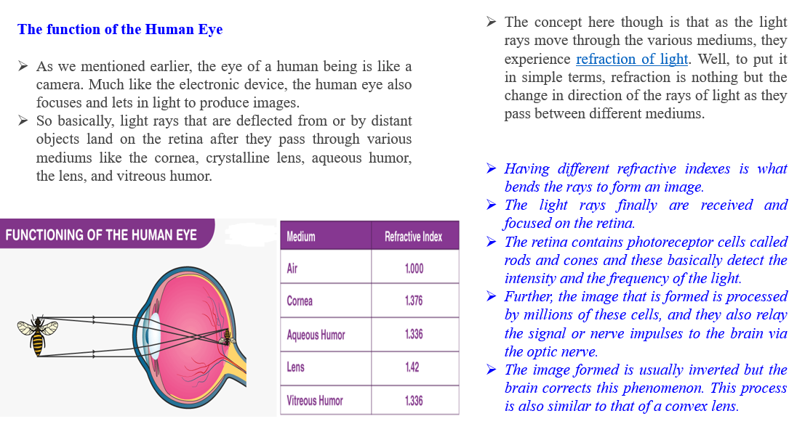

5b. Describe the architecture of lungs and gas exchange mechanism.

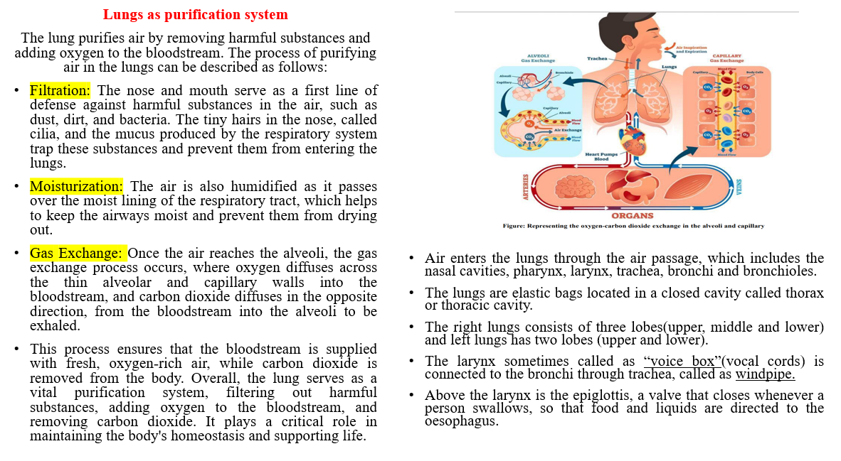
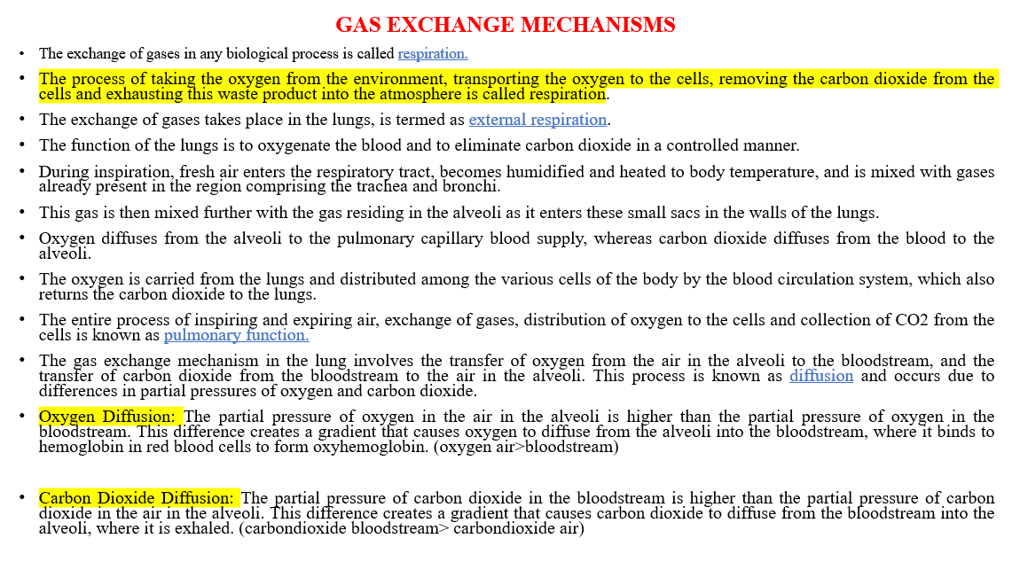

6a. Explain the kidney as filtration system.

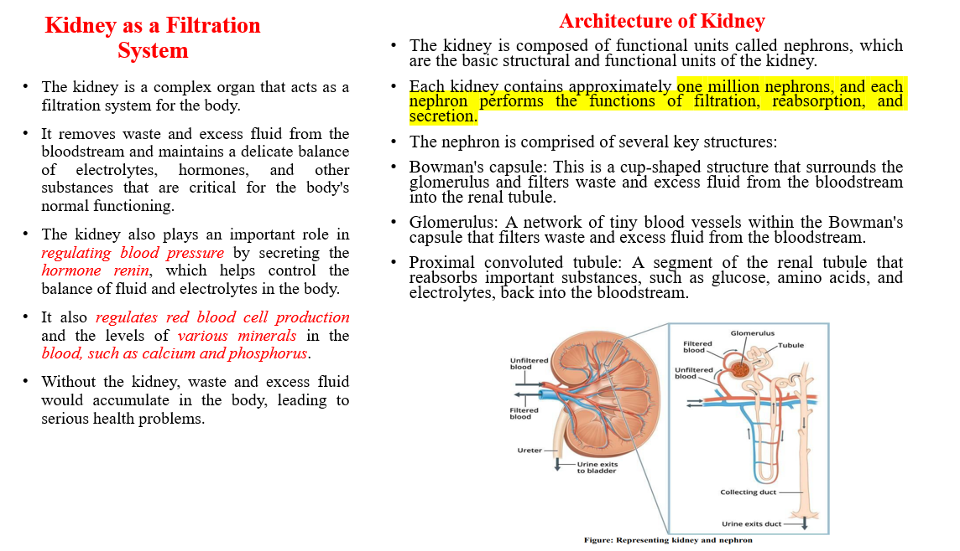
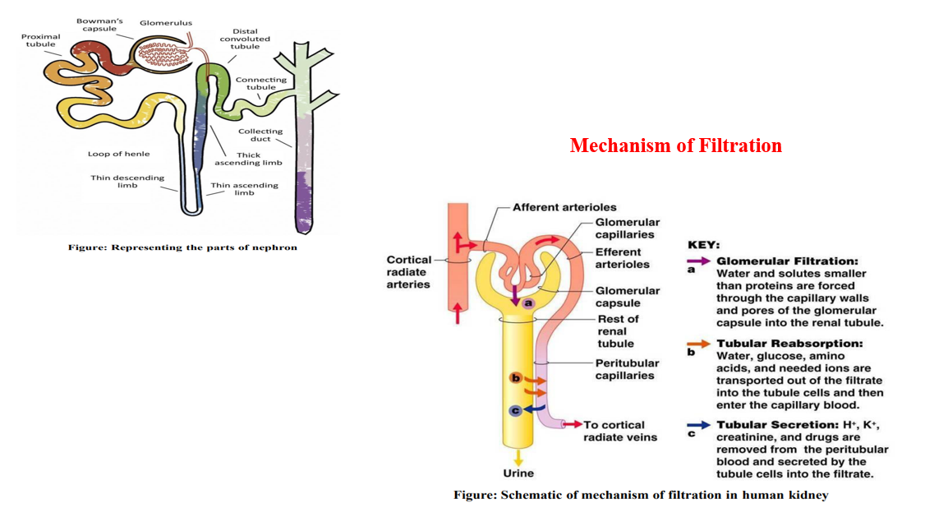

6b. Write a short note on Chronic Obstructive Pulmonary Disease (COPD).
Chronic Obstructive Pulmonary Disease (COPD) is a progressive, incurable respiratory condition characterized by persistent airflow limitation and an abnormal inflammatory response of the lungs. It is a major cause of morbidity and mortality worldwide, leading to a reduced quality of life and a significant economic burden on healthcare systems.
COPD is an umbrella term encompassing two primary conditions:
- Chronic bronchitis – inflammation of the bronchial tubes with excessive mucus production.
- Emphysema – damage and enlargement of the air sacs (alveoli) in the lungs.
Causes and Risk Factors
The primary cause of COPD is long-term exposure to harmful particles or gases, most commonly from cigarette smoking. However, several other risk factors include:
- Smoking: Accounts for about 85–90% of COPD cases. Passive (second-hand) smoke also contributes.
- Environmental Exposure: Long-term inhalation of dust, chemical fumes, air pollutants, and biomass fuels.
- Occupational Hazards: Prolonged exposure to industrial dust and chemicals in the workplace.
- Genetics: A rare genetic disorder called Alpha-1 Antitrypsin Deficiency can lead to early-onset COPD.
- Respiratory Infections: Frequent childhood respiratory infections can increase the risk.
- Age and Gender: More common in people over 40, and historically more prevalent in males, though rising in females due to increased smoking.

Pathophysiology
COPD involves chronic inflammation of the airways, lung tissue, and pulmonary blood vessels. The disease process includes:
- Airway Inflammation: Continuous exposure to irritants leads to infiltration of inflammatory cells like neutrophils, macrophages, and T-lymphocytes.
- Bronchial Remodelling: Structural changes in airways due to chronic inflammation cause narrowing and obstruction.
- Mucus Hypersecretion: Goblet cell hyperplasia and enlarged mucus glands produce excess sputum, obstructing airflow.
- Alveolar Damage (Emphysema): Destruction of alveolar walls reduces the surface area for gas exchange and leads to lung hyperinflation.
- Impaired Gas Exchange: Loss of elasticity and alveolar collapse reduce oxygen absorption and carbon dioxide elimination.

Symptoms of COPD
COPD symptoms usually develop gradually and worsen over time:
- Chronic Cough: Often the first symptom, may be dry or productive.
- Sputum Production: Frequent mucus, especially in chronic bronchitis.
- Shortness of Breath (Dyspnea): Especially during physical activity and worsens with disease progression.
- Wheezing: Due to narrowed airways.
- Fatigue and Weakness: Caused by reduced oxygen levels.
- Chest Tightness and recurrent respiratory infections.

Diagnosis
Early diagnosis is crucial for managing COPD effectively. Diagnosis is based on:
- Clinical History:
  - Symptoms (chronic cough, sputum, breathlessness)
  - Risk factor exposure (smoking, environmental)
- Physical Examination:
  - Wheezing, barrel chest, use of accessory muscles
- Pulmonary Function Tests (PFTs):
  - Spirometry: Gold standard test. A post-bronchodilator FEV1/FVC ratio < 0.70 confirms persistent airflow limitation.
- Chest X-ray/CT scan:
  - Shows hyperinflation, flattened diaphragm, or emphysematous changes.
- Blood Tests:
  - Alpha-1 antitrypsin deficiency screening in young or non-smoking individuals.
  - Arterial blood gas analysis in severe cases.

Staging and Classification
The Global Initiative for Chronic Obstructive Lung Disease (GOLD) categorizes COPD into stages based on FEV1 (% predicted):
- GOLD 1 (Mild): FEV1 ≥ 80%
- GOLD 2 (Moderate): 50% ≤ FEV1 < 80%
- GOLD 3 (Severe): 30% ≤ FEV1 < 50%
- GOLD 4 (Very Severe): FEV1 < 30%

Management and Treatment
Although COPD is not curable, its progression can be slowed, and symptoms can be managed through a comprehensive approach:
1. Lifestyle Modifications:
- Smoking cessation: Most effective intervention.
- Avoidance of pollutants and occupational hazards.
- Healthy diet and regular exercise.
2. Pharmacologic Therapy:
- Bronchodilators (β2-agonists, anticholinergics): Relieve breathlessness.
- Inhaled corticosteroids (ICS): For patients with frequent exacerbations.
- Combination therapy: LABA + ICS or LABA + LAMA.
- Phosphodiesterase-4 inhibitors: For chronic bronchitis phenotype.
- Mucolytics: To reduce mucus thickness.
3. Vaccination:
- Annual influenza and pneumococcal vaccines reduce infections.
4. Pulmonary Rehabilitation:
- Exercise training, education, and nutritional advice to improve quality of life.
5. Oxygen Therapy:
- For patients with chronic hypoxemia (SpO₂ ≤ 88%).
6. Surgical Options:
- Lung volume reduction surgery or lung transplant in advanced emphysema.

Module – 4

7a. Write a short note on:
(i) Lotus Leaf effect
(ii) Shark skin

(i) Lotus Leaf Effect
The Lotus Leaf Effect refers to the self-cleaning property observed in the surface of lotus leaves. This phenomenon is due to the super hydrophobicity of the leaf surface, which is characterized by very high-water contact angles (greater than 150°).
- The surface of the lotus leaf is covered with microscopic waxy structures that minimize the adhesion of water and dirt.
- Water droplets roll off easily, picking up dust and contaminants — a process known as self-cleaning.
- This effect has inspired numerous biomimetic applications, such as self-cleaning windows, water-repellent fabrics, anti-corrosion coatings, and paints.
Key Concepts: Super hydrophobicity, micro/nano surface structure, self-cleaning surfaces, biomimetics.

(ii) Shark Skin
The Shark Skin Effect refers to the unique texture of shark skin, which reduces drag and resists biofouling (accumulation of microorganisms on surfaces).
- Shark skin is composed of tiny, overlapping scales called dermal denticles that have riblet-like patterns.
- These riblets channel water efficiently, reducing friction and turbulent flow, allowing sharks to swim faster with less effort.
- Shark skin also prevents the attachment of algae and bacteria, leading to applications in antifouling surfaces.
Biomimetic Applications:
- Drag-reducing swimsuits and aircraft coatings,
- Antibacterial and anti-fouling hospital surfaces,
- Efficient designs for ships and submarines.
Key Concepts: Riblet structure, drag reduction, antifouling, biomimicry.

7b. Illustrate the HBO’s and PFC’s as human blood substitutes.
Due to the increasing demand and limited availability of donor blood, blood substitutes have been developed as alternatives for transfusion in emergencies, surgeries, and battlefield scenarios. Two of the most widely studied classes of artificial blood substitutes are:

1. Hemoglobin-Based Oxygen Carriers (HBOs)
Definition:
HBOs are blood substitutes derived from purified, modified hemoglobin (Hb) — the oxygen-carrying protein found in red blood cells (RBCs).
Features & Functions:
- Designed to carry and deliver oxygen to tissues, mimicking the function of natural hemoglobin.
- Can be derived from human, bovine (cow), or recombinant sources.
- Modified chemically (e.g., polymerized or PEGylated) to increase stability, prevent renal toxicity, and avoid immune responses.
Advantages:
- No need for cross-matching (universal compatibility).
- Long shelf-life (no refrigeration needed).
- Useful in trauma, surgery, and remote battlefield conditions.
Limitations:
- Short half-life in circulation.
- Risk of vasoconstriction and oxidative stress.
- Not yet widely approved for clinical use in most countries.
Examples:
- Hemopure (bovine-derived Hb)
- PolyHeme
- HemAssist

2. Perfluorocarbons (PFCs)
Definition:
PFCs are synthetic, inert organic compounds that can dissolve large volumes of gases, particularly oxygen and carbon dioxide.
Features & Functions:
- Capable of transporting and releasing oxygen due to high gas solubility.
- Require supplemental oxygen administration to work effectively.
- Delivered in emulsion form (tiny PFC droplets suspended in a liquid).
Advantages:
- Extremely small particle size — can reach capillaries and damaged tissues that RBCs can't.
- No risk of infection transmission.
- Long shelf-life and easy storage.
Limitations:
- Oxygen delivery capacity is lower than that of natural blood.
- Requires high inspired oxygen concentration.
- Some PFCs have been associated with flu-like symptoms or liver burden.
Examples:
- Oxygent
- Fluosol-DA
- Perftoran (approved in Russia)

8a. Write a short note on:
(i) Photovoltaic cells
(ii) Bionic leaf

(i) Photovoltaic Cells
Definition:
Photovoltaic (PV) cells, commonly known as solar cells, are devices that convert sunlight directly into electricity using the photovoltaic effect.
Working Principle:
When sunlight hits a PV cell, photons from the light strike the semiconductor material (typically silicon), exciting electrons and creating electron-hole pairs. These charge carriers are separated by the electric field in the cell, generating a direct current (DC).
Key Components:
- Semiconductor layers (e.g., silicon)
- Conductive metal contacts
- Anti-reflective coating to capture more sunlight
Applications:
- Solar panels for homes and industries
- Power sources for satellites and space probes
- Portable solar chargers and traffic signs
Advantages:
- Renewable and clean energy source
- Low operating cost after installation
- Scalable for various energy needs

(ii) Bionic Leaf
Definition:
A bionic leaf is a bio-inspired artificial photosynthesis system that mimics natural leaves by converting sunlight, water, and carbon dioxide into energy-rich fuels and useful chemicals.
Working Mechanism:
- Developed using solar energy, catalysts, and microbes.
- First, solar energy splits water into hydrogen and oxygen.
- Then, engineered bacteria (e.g., Ralstonia eutropha) use the hydrogen to convert CO₂ into liquid fuels like isopropanol or biomass.
Significance:
- It merges biological and artificial systems for sustainable fuel production.
- Operates at an efficiency higher than natural photosynthesis.
- Can aid in carbon capture and renewable chemical synthesis.
Applications:
- Clean fuel generation
- Carbon-neutral energy solutions
- Agricultural fertilizer production (in newer versions)

8b. Describe the engineering applications of GPS and Velcro technology.
Global Positioning System (GPS) – Engineering Applications
Definition:
GPS is a satellite-based navigation system that provides location, velocity, and time information to users anywhere on Earth.
Engineering Applications:
- Civil Engineering & Construction:
  - Surveying and Mapping: High-precision GPS enables accurate land surveys and digital terrain modeling.
  - Machine Guidance: GPS is used in earth-moving equipment for precise grading and excavation.
  - Site Management: Real-time location tracking helps manage construction logistics and equipment.
- Transportation Engineering:
  - Traffic Monitoring: GPS aids in tracking traffic patterns and congestion for efficient urban planning.
  - Fleet Management: Used for real-time monitoring of public transport and logistics fleets.
  - Navigation Systems: Integrated into vehicles for route optimization and accident avoidance.
- Geotechnical Engineering:
  - Structural Monitoring: Tracks deformation in bridges, dams, and tall structures with sub-centimeter accuracy.
  - Seismic Studies: Assists in monitoring tectonic movements and post-disaster analysis.
- Environmental Engineering:
  - Disaster Management: Helps in evacuation planning, rescue operations, and damage assessment during natural disasters.
  - Resource Management: Used in tracking deforestation, water bodies, and pollution sources.

Velcro Technology – Engineering Applications
Definition:
Velcro is a brand name for a hook-and-loop fastening system, inspired by the way burrs stick to animal fur. Invented by George de Mestral in 1941, it mimics biomimicry in design.
Engineering Applications:
- Aerospace Engineering:
  - Cable Management: Used to organize wiring and components in spacecraft and aircraft.
  - Tool Restraints: Keeps tools and devices secure in zero-gravity environments (e.g., NASA's space missions).
- Automotive Engineering:
  - Interior Fastening: Secures carpets, headliners, and removable panels.
  - Accessory Attachments: Used for quick fastening of seat covers and portable electronics.
- Textile and Wearable Engineering:
  - Adaptive Clothing: Used in medical and military uniforms for quick removal or fastening.
  - Wearable Sensors: Holds sensors or battery packs in health-monitoring wearables.
- Robotics & Prosthetics:
  - Quick Assembly: Assists in rapid assembly or disassembly of modular robots.
  - Prosthetic Attachments: Provides comfort and secure attachment for wearable prosthetic limbs.

Module – 5

9a. Analyze the bio-engineering solutions for muscular dystrophy and osteoporosis.
1. Muscular Dystrophy (MD)
Definition:
Muscular dystrophy is a group of genetic disorders characterized by progressive weakness and degeneration of skeletal muscles. The most common type is Duchenne Muscular Dystrophy (DMD) caused by mutations in the dystrophin gene.
Bio-Engineering Solutions for MD:
- Gene Therapy:
  - Introduction of functional copies of the dystrophin gene using viral vectors (e.g., AAV – adeno-associated virus).
  - Techniques like CRISPR/Cas9 are used to correct gene mutations at the DNA level.
- Stem Cell Therapy:
  - Use of induced pluripotent stem cells (iPSCs) or mesenchymal stem cells (MSCs) to regenerate damaged muscle tissues.
  - Engineered muscle cells are injected into the body to restore function.
- Exon Skipping Technology:
  - Synthetic antisense oligonucleotides (ASOs) are used to skip faulty exons during mRNA processing, producing partially functional dystrophin.
- Tissue Engineering:
  - Creation of 3D muscle tissues using biocompatible scaffolds to study disease progression and test therapies.
  - Scaffold materials (collagen, fibrin) mimic natural extracellular matrix (ECM).
- Bio-Sensors and Wearables:
  - Devices for muscle activity monitoring, gait analysis, and mobility tracking to assess therapy effectiveness.

2. Osteoporosis
Definition:
Osteoporosis is a metabolic bone disease where bone mineral density (BMD) decreases, leading to fragile bones and increased fracture risk, especially in postmenopausal women and the elderly.
Bio-Engineering Solutions for Osteoporosis:
- Biomaterials for Bone Regeneration:
  - Use of biodegradable scaffolds made of hydroxyapatite, tricalcium phosphate, or bioglass to support bone regrowth.
  - These materials are seeded with osteoblasts or stem cells.
- Bone Tissue Engineering:
  - Incorporation of growth factors (e.g., BMPs – Bone Morphogenetic Proteins) into scaffolds to stimulate bone healing and regeneration.
- Smart Drug Delivery Systems:
  - Nanotechnology-enabled targeted delivery of anti-resorptive or bone-forming drugs (like bisphosphonates, teriparatide) to affected bone sites.
  - Hydrogel-based systems allow controlled drug release.
- 3D Bioprinting of Bone Constructs:
  - Customized bone grafts are created using patient-specific data from CT/MRI.
  - These bio-printed structures can integrate with native bone.
- Bone Density Monitoring Devices:
  - Use of non-invasive imaging tools (DEXA scans integrated with AI) for early detection and tracking of osteoporosis.
  - Development of wearable devices for real-time biomechanical stress analysis.

9b. Write a short note on self-healing bio-concrete.
Self-healing bio-concrete is an advanced construction material designed to automatically repair cracks in concrete without human intervention. It integrates biological agents, mainly specific types of bacteria, into the concrete matrix, enabling it to heal itself when cracks occur.

Mechanism:
- Bacterial Activation:
  - The most commonly used bacteria are spore-forming bacteria like Bacillus subtilis or Bacillus pasteurii.
  - These bacteria remain dormant inside the concrete until water enters through cracks.
- Calcium Carbonate Precipitation:
  - On contact with water, the bacteria become active and consume a nutrient source (usually calcium lactate).
  - As a metabolic by-product, they precipitate calcium carbonate (CaCO₃), which fills and seals the crack.

Components:
- Bacterial spores
- Nutrient (e.g., calcium lactate)
- Water (activator)
- Carrier materials like silica gel or clay pellets to protect bacteria during mixing

Advantages:
- Increases lifespan of concrete structures
- Reduces maintenance costs
- Improves durability and water-tightness
- Environmentally friendly and sustainable solution

Applications:
- Tunnels, bridges, basements, marine structures, and other infrastructure exposed to stress and harsh environments.

10a. Examine the bioimaging and artificial intelligence for disease diagnosis.
Modern disease diagnosis is increasingly relying on technological advancements for greater accuracy, speed, and early detection. Two rapidly advancing fields — bioimaging and artificial intelligence (AI) — are revolutionizing diagnostic medicine by providing clinicians with deeper insights into patient health and enabling data-driven, automated decision-making. Bioimaging refers to the techniques used to visualize biological processes and structures in the human body. It plays a vital role in detecting, monitoring, and understanding diseases at anatomical, molecular, and cellular levels.
Common Bioimaging Modalities:
- X-rays: For bone fractures, chest infections, and dental analysis.
- CT (Computed Tomography): Provides 3D images for detecting tumors, internal bleeding, and organ damage.
- MRI (Magnetic Resonance Imaging): Offers detailed images of soft tissues like the brain, spine, and joints.
- Ultrasound: Used for fetal imaging, organ inspection, and guided biopsies.
- PET and SPECT Scans: Highlight metabolic activity, ideal for detecting cancer or neurological disorders.
- Fluorescence and Optical Imaging: Used in cellular and molecular biology for studying tissue interactions.
Significance:
- Non-invasive and real-time visualization
- Enables early-stage disease detection
- Guides surgical and therapeutic interventions
- Allows for longitudinal monitoring of disease progression

Artificial Intelligence in Disease Diagnosis
Artificial Intelligence (AI) uses machine learning (ML), deep learning (DL), and neural networks to process large volumes of medical data for pattern recognition, classification, and prediction.
Applications in Diagnosis:
- Image Analysis:
  - AI algorithms analyze medical images to detect abnormalities (e.g., tumors in MRIs, pneumonia in chest X-rays).
  - Tools like Google’s DeepMind and IBM Watson Health support radiologists in interpreting scans.
- Predictive Diagnostics:
  - AI can predict the likelihood of disease development based on genetic data, lifestyle, or previous history.
  - Example: Predicting the onset of diabetes, Alzheimer’s, or cardiovascular diseases.
- Decision Support Systems:
  - AI systems assist clinicians by suggesting diagnoses or treatment options based on electronic health records (EHRs).
- Pathology and Genomics:
  - AI enables automated analysis of biopsy slides, blood samples, and gene sequences.

Integration of Bioimaging and AI
Combining AI with bioimaging leads to smart diagnostics, where AI models enhance the interpretation of imaging data.
Key Benefits:
- Improved accuracy and consistency
- Faster processing times and automated reporting
- Detection of subtle patterns invisible to the human eye
- Enables personalized medicine through integrated analysis of imaging and clinical/genomic data
Examples:
- AI-based breast cancer screening using mammograms
- Lung nodule detection in chest CT scans
- Brain tumor segmentation from MRI using convolutional neural networks (CNNs)

Challenges and Limitations
- Data privacy and security concerns
- Need for large annotated datasets for training AI models
- Risk of bias in AI algorithms
- Integration with clinical workflow is still evolving
- Interpretability: AI’s “black box” nature makes it difficult to understand decision logic

10b. Explain the process of biomining via microbial surface adsorption.
Biomining is a biotechnological method of extracting metals from ores and mine waste using microorganisms. Among the various mechanisms involved, one significant process is microbial surface adsorption, where metal ions are adsorbed onto the microbial cell surface without the need for cellular metabolism.

Microbial surface adsorption refers to the passive binding of metal ions to the surface of microbial cells. This occurs primarily due to the presence of functional groups such as:
- Carboxyl (–COOH)
- Hydroxyl (–OH)
- Amino (–NH₂)
- Phosphate (–PO₄³⁻)
These groups are present on the cell wall of bacteria, fungi, or algae and interact with metal cations, allowing the cells to bind metals from solutions.

Microorganisms Used in Biomining
- Bacteria: Acidithiobacillus ferrooxidans, Leptospirillum ferrooxidans
- Fungi: Aspergillus niger, Penicillium spp.
- Algae: Chlorella spp., Spirogyra spp.
Steps in Biomining via Surface Adsorption
Step 1: Contact with Metal-Bearing Material
The microbes are introduced into a slurry or heap that contains the metal-rich ore or waste.
Step 2: Metal Ion Release
Metals such as Cu²⁺, Zn²⁺, or Ni²⁺ dissolve in the aqueous phase due to bioleaching or natural solubilization.
Step 3: Surface Binding
Metal ions in the solution bind to the negatively charged functional groups on the microbial cell walls through:
- Ion exchange
- Complexation
- Electrostatic interactions
Step 4: Bioaccumulation (optional)
In some cases, after adsorption, the metal ions may enter the cell and accumulate internally, though surface adsorption is usually extracellular and metabolism-independent.

Advantages of Surface Adsorption in Biomining
- Eco-friendly: Reduces chemical usage in metal recovery
- Cost-effective: Operates at ambient temperature and pressure
- Selective: Certain microbes show preferential binding to specific metals
- Applicable to low-grade ores and mine waste

Applications
- Recovery of heavy metals (e.g., uranium, gold, copper, zinc)
- Treatment of acidic mine drainage
- Bioremediation of contaminated soils and waters

